**DEEP LEARNING FUNDUS IMAGE ANALYSIS FOR**

**EARLY DETECTION OF DIABETIC**

**RETINOPATHY**

**NALAIYA THIRAN PROJECT REPORT**

**IBM-PROJECT-9489-1659011852**

**TEAM ID :PNT2022TMID08398**

**Submitted by**

**DIVYA SHREE P.K (814319104006)**

**ABITHA .A (814319104001)**

**GAYATHRI K.S (814319104012)**

**DOWMIKA .C (814319104007)**

**in partial fulfillment for the award of the degree**

**of**

**BATCHELOR OF ENGINNERING**

**IN**

**COMPUTER SCIENCE AND ENGINEERING**

**DHANALAKSHMI SRINIVASAN ENGINEERING COLLEGE**

**(AUTONOMOUS)**

**PERAMBALUR-621212**

**TABLE OF CONTENTS**

**1. INTRODUCTION………………………………………………………….1**

1.1 Project Overview

1.2 Purpose

**2. SURVEY LITERATURE………………………………………………....3**

2.1 Existing Problem

2.2 References

2.3 problem Statement Definition

**3.IDEATION & PROPOSED SOLUTION………………………………………………13**

3.1 Empathy Map

3.2 Ideation & Brainstorming

3.3 Proposed Solution Fit

**4. REQUIRMENT ANALYSIS……………………………………………………………18**

4.1 Functional requirement

4.2 Non-Functional requirement

**5. PROJECT DESIGN…………………………………………………………………….19**

5.1 Data Flow Diagrams

5.2 Solution &Technical Architecture

5.3 User Stories

**6. PROJECT PLANNING & SCHEDULING……………………………………………21**

6.1 Sprint planning &Estimation

6.2 Sprint Delivery Schedule

6.3 Reports from JIRA

**7.CODING & SOLUTIONING………………………………………………………….23**

7.1 Feature 1

7.2 Feature 2

7.3 Data base schema

**8. TESTING…………………………………………………………………...27**

8.1 Test Case

8.2 User Acceptance Testing

**9.RESULTS…………………………………………………………………...29**

9.1performance metrics

**10.ADVANTAGES& DISADVANTAGES…………………………………31**

**11. CONCLUSION…………………………………………………………...32**

**12. FUTURE SCOPE………………………………………………………...33**

**13. APPENDIX……………………………………………………………….34**

Source Code

GitHub & Project Demo Link

**ABSTRACT:**

This project describes automatic diabetic retinopathy using deep learning algorithm. Different types diabetic stages is recognized using convolution neural network.deep learning system that identifies referable diabetic retinopathy comparably or better than presented in the previous studies, although we use only a small fraction of images (<1/4) in training but are aided with higher image resolutions.We also provide novel results for five different screening and clinical grading systems for diabetic retinopathy and macular edema classification, including state-of-the-art results for accurately classifying images according to clinical five-grade diabetic retinopathy and for the first time for the four-grade diabetic macular edema scales.

**1.INTRODUCTION:**

**1.1PROJECT OVERVIEW:**

Diabetic Eye Disease (DED) comprises a group of eye conditions, which include Diabetic Retinopathy, Diabetic Macular Edema, Glaucoma and Cataract. All types of DED have the potential to cause severe vision loss and blindness in patients from 20 to 74 years of age. According to the International Diabetes Federation (IDF) statement, about 425 million citizens worldwide suffered from diabetes in 2017. By 2045, this is forecast to increase to 692 million. Medical, social and economic complications of diabetes impact substantially on public health, with diabetes being the world's fourth largest cause of death. The effects of diabetes can be observed in different parts of a person's body, including the retina.shows the normal anatomical structures of the retina. illustrates a complication of DED in a retina. Serious DED begins with an irregular development of blood vessels, damage of the optic nerve and the formation of hard exudates in the macula region. Four types of DED threaten eye vision, and they are briey described in the following subsection. Diabetic Retinopathy (DR) is caused by damage to blood vessels of the light sensitive tissue (retina) at the back of the eye.

The retina is responsible for sensing light and sending a signal to brain. The brain decodes those signals to see the objects around. There are two stages of DR: early DR and advanced DR. In early DR, new blood vessels do not developing (proliferating) and this is generally known as nonproliferative diabetic retinopathy (NPDR). The walls of the blood vessels inside the retina weaken due to NPDR. Narrower bulges (microaneurysms) protrude from the narrower vessel surfaces, often dripping uid and blood into the eye. Large retinal vessels also start dilating and become irregular in diameter. As more blood vessels become blocked, NPDR progresses from mild to severe.

**2. LITEATURE SURVEY:**

**2.1 EXISTING PROBLEM:**

Majority of the existing literature extract the blood vessels or detect the lesions separately and the tools and techniques used are also different that make the system design more complex.

* The super-pixel classification-based approach is proposed by including features from super-pixel level, which significantly improves the disc and cup detection. However, it has a bias of underestimating large cups and overestimating small cups due -to the dominance of medium sized cups.
* Cheng *et al.* proposed super-pixel classification-based approach by including features from super-pixel level, which significantly improves the optic disc and cup detection.
* However, it has a bias of underestimating large cups and overestimating small cups due -to the dominance of medium sized cups used to train the model.
* Very often, these methods rely on the contrast between the cup and the neuro-retinal rim to find the cup boundary for CDR computation and can be challenging to use effectively when the contrast is weak.
* Assessment of raised intraocular pressure (IOP) is the method previously used to detect glaucoma.
* In the previous work on “Classifying glaucoma with image-based features from fundus photographs”, the features are normally computed at the image-level and we use image features for a binary classification between glaucomatous and healthy subjects.

**2.2 REFERENCES:**

**TITLE 2.1 : Automatic Cataract Detection And Grading Using**

**Deep Convolutional Neural Network:**

**AUTHOR:** LinglinZhanga, Jianqiang Lia

**YEAR:**2017

**DESCRIPTION:** Cataract is one of the most prevalent causes of blindness in the industrialized world, accounting for more than 50% of blindness. Early detection and treatment can reduce the suffering of cataract patients and prevent visual impairment from turning into blindness. But the expertise of trained eye specialists is necessary for clinical cataract detection and grading, which may cause difficulties to everybody's early intervention due to the underlying costs. Existing studies on automatic cataract detection and grading based on fundus images utilize a predefined set of image features that may provide an incomplete, redundant, or even noisy representation. This paper aims to investigate the performance and efficiency by using Depp Convolutional Neural Network (DCNN) to detect and grad cataract automatically, it also visualize some of the feature maps at pool5 layer with their high-order empirical semantic meaning, providing a explanation to the feature representation extracted by DCNN.

**TITLE 2.2 : Artificial intelligence and deep learning in ophthalmology**

**AUTHOR:** Daniel Shu Wei Ting

**YEAR:**2020

**DESCRIPTION:** Artificial intelligence (AI) based on deep learning (DL) has sparked tremendous global interest in recent years. DL has been widely adopted in image recognition, speech recognition and natural language processing, but is only beginning to impact on healthcare. In ophthalmology, DL has been applied to fundus photographs, optical coherence tomography and visual fields, achieving robust classification performance in the detection of diabetic retinopathy and retinopathy of prematurity, the glaucoma-like disc, macular oedema and age-related macular degeneration. DL in ocular imaging may be used in conjunction with telemedicine as a possible solution to screen, diagnose and monitor major eye diseases for patients in primary care and community settings. Nonetheless, there are also potential challenges with DL application in ophthalmology, including clinical and technical challenges, explainability of the algorithm results, medicolegal issues, and physician and patient acceptance of the AI ’black-box’ algorithms.

**TITLE 2.3: Diabetic retinopathy detection through deep learning techniques:** A review

**AUTHOR:** Wejdan L. Alyoubi

**YEAR:**2020

**DESCRIPTION:** Diabetic Retinopathy (DR) is a common complication of diabetes mellitus, which causes lesions on the retina that effect vision. If it is not detected early, it can lead to blindness. Unfortunately, DR is not a reversible process, and treatment only sustains vision. DR early detection and treatment can significantly reduce the risk of vision loss. The manual diagnosis process of DR retina fundus images by ophthalmologists is time-, effort-, and costconsuming and prone to misdiagnosis unlike computer-aided diagnosis systems. Recently, deep learning has become one of the most common techniques that has achieved better performance in many areas, especially in medical image analysis and classification. Convolutional neural networks are more widely used as a deep learning method in medical image analysis and they are highly effective. For this article, the recent state-of-theart methods of DR color fundus images detection and classification using deep learning techniques have been reviewed and analyzed. Furthermore, the DR available datasets for the color fundus retina have been reviewed. Difference challenging issues that require more investigation are also discussed.

**TITLE 2.4**: **Computer-Aided Diagnosis of Glaucoma Using Fundus Images:** AReview

**AUTHOR:** Yuki Hagiwara , Joel En Wei Koh

**YEAR:**2018

**DESCRIPTION:** Glaucoma is an eye condition which leads to permanent blindness when the disease progresses to an advanced stage. It occurs due to inappropriate intraocular pressure within the eye, resulting in damage to the optic nerve. Glaucoma does not exhibit any symptoms in its early stage and thus, it is important to diagnose early to prevent blindness. Fundus photography is widely used by ophthalmologists to assist in diagnosis of glaucoma and is cost-effective. Methods: The morphological features of the disc that is characteristic of glaucoma are clearly seen in the fundus images. However, manual inspection of the acquired fundus images may be prone to inter-observer variation. Therefore, a computer-aided detection (CAD) system is proposed to make an accurate, reliable and fast diagnosis of glaucoma based on the optic nerve features of fundus imaging. In this paper, we reviewed existing techniques to automatically diagnose glaucoma.

**TITLE 2.5: Deep Learning Based Method for Computer Aided**

**Diagnosis of Diabetic Retinopathy**

**AUTHOR:** Omar Dekhil*a*, Ahmed Naglah*a*

**YEAR:**2019

**DESCRIPTION:** Diabetic retinopathy (DR) is a retinal disease caused by the high blood sugar levels that may damage and block the blood vessels feeding the retina. In the early stages of DR, the disease is asymptomatic; however, as the disease advances, a possible sudden loss of vision and blindness may occur. Therefore, an early diagnosis and staging of the disease is required to possibly slow down the progression of the disease and improve control of the symptoms. In response to the previous challenge, we introduce a computer aided diagnosis tool based on convolutional neural networks (CNN) to classify fundus images into one of the five stages of DR. The proposed CNN consists of a preprocessing stage, five stage convolutional, rectified linear and pooling layers followed by three fully connected layers. Transfer learning was adopted to minimize overfitting by training the model on a larger dataset of 3.2 million images (i.e. ImageNet) prior to the use of the model on the APTOS 2019 Kaggle DR dataset.

**TITLE 2.6: Using a Deep Learning Algorithm and Integrated Gradients Explanation to Assist Grading for Diabetic Retinopathy:**

**AUTHOR:** Ehsan Rahimy

**YEAR:**2018

**DESCRIPTION:** To understand the impact of deep learning diabetic retinopathy (DR) algorithms on physician readers in computer-assisted settings. Design: Evaluation of diagnostic technology. Participants: One thousand seven hundred ninety-six retinal fundus images from 1612 diabetic patients. Methods: Ten ophthalmologists (5 general ophthalmologists, 4 retina specialists, 1 retina fellow) read images for DR severity based on the International Clinical Diabetic Retinopathy disease severity scale in each of 3 conditions: unassisted, grades only, or grades plus heatmap. Grades-only assistance comprised a histogram of DR predictions (grades) from a trained deep-learning model. For grades plus heatmap, we additionally showed explanatory heatmaps. Main Outcome Measures: For each experiment arm, we computed sensitivity and specificity of each reader and the algorithm for different levels of DR severity against an adjudicated reference standard. We also measured accuracy (exact 5-class level agreement and Cohen’s quadratically weighted k), reader-reported confidence (5-point Likert scale), and grading time.

**TITLE 2.7: Image Processing, Textural Feature Extraction and Transfer Learning based detection of Diabetic Retinopathy**

**AUTHOR:**AnjanaUmapathy

**YEAR:**2019

**DESCRIPTION:** Diabetic Retinopathy (DR) is one of the most common causes of blindness in adults. The need for automating the detection of DR arises from the deficiency of ophthalmologists in certain regions where screening is done, and this paper is aimed at mitigating this bottleneck. Images from publicly available datasets STARE, HRF, and MESSIDOR along with a novel dataset of images obtained from the Retina Institute of Karnataka are used for training the models. This paper proposes two methods to automate the detection. The first approach involves extracting features using retinal image processing and textural feature extraction, and uses a Decision Tree classifier to predict the presence of DR. The second approach applies transfer learning to detect DR in fundus images. The accuracies obtained by the two approaches are 94.4% and 88.8% respectively, which are competent to current automation methods. A comparison between these models is made. On consultation with Retina Institute of Karnataka, a web application which predicts the presence of DR that can be integrated into screening centres is made.

**TITLE 2.8: Deep Transfer Learning Models for Medical Diabetic Retinopathy Detection:**

**AUTHOR:** NourEldeen M. Khalifa1

**YEAR:**2019

**DESCRIPTION:** Diabetic retinopathy (DR) is the most common diabetic eye disease worldwide and a leading cause of blindness. The number of diabetic patients will increase to 552 million by 2034, as per the International Diabetes Federation (IDF). Aim: With advances in computer science techniques, such as artificial intelligence (AI) and deep learning (DL), opportunities for the detection of DR at the early stages have increased. This increase means that the chances of recovery will increase and the possibility of vision loss in patients will be reduced in the future. Methods: In this paper, deep transfer learning models for medical DR detection were investigated. The DL models were trained and tested over the Asia Pacific Tele-Ophthalmology Society (APTOS) 2019 dataset. According to literature surveys, this research is considered one the first studies to use of the APTOS 2019 dataset, as it was freshly published in the second quarter of 2019. The selected deep transfer models in this research were AlexNet, Res-Net18, SqueezeNet, GoogleNet, VGG16, and VGG19. These models were selected, as they consist of a small number of layers when compared to larger models, such as DenseNet and InceptionResNet. Data augmentation techniques were used to render the models more robust and to overcome the overfitting problem

**TITLE 2.9: Automatic Detection of Diabetic Eye Disease Through Deep Learning Using Fundus Images: A Survey**

**AUTHOR:** RUBINA SARKI , KHANDAKAR AHMED

**YEAR:**2020

**DESCRIPTION:** Diabetes Mellitus, or Diabetes, is a disease in which a person's body fails to respond to insulin released by their pancreas, or it does not produce sufcient insulin. People suffering from diabetes are at high risk of developing various eye diseases over time. As a result of advances in machine learning techniques, early detection of diabetic eye disease using an automated system brings substantial benets over manual detection. A variety of advanced studies relating to the detection of diabetic eye disease have recently been published. This article presents a systematic survey of automated approaches to diabetic eye disease detection from several aspects, namely: i) available datasets, ii) image preprocessing techniques, iii) deep learning models and iv) performance evaluation metrics. The survey provides a comprehensive synopsis of diabetic eye disease detection approaches, including state of the art eld approaches, which aim to provide valuable insight into research communities, healthcare professionals and patients with diabetes**.**

**TITLE 2.10: Evaluation of deep convolutional neural networks for glaucoma**

**Detection:**

**AUTHOR:** Sang Phan1 · Shin’ichi Satoh1

**YEAR:**2019

**DESCRIPTION:** To investigate the performance of deep convolutional neural networks (DCNNs) for glaucoma discrimination using color fundus images Study design A retrospective study Patients and methods To investigate the discriminative ability of 3 DCNNs, we used a total of 3312 images consisting of 369 images from glaucoma-confirmed eyes, 256 images from glaucoma-suspected eyes diagnosed by a glaucoma expert, and 2687 images judged to be nonglaucomatous eyes by a glaucoma expert. We also investigated the effects of image size on the discriminative ability and heatmap analysis to determine which parts of the image contribute to the discrimination. Additionally, we used 465 poor-quality images to investigate the effect of poor image quality on the discriminative ability. Results Three DCNNs showed areas under the curve (AUCs) of 0.9 or more. The AUC of the DCNN using glaucomaconfirmed eyes against nonglaucomatous eyes was higher than that using glaucoma-suspected eyes against nonglaucomatous eyes by approximately 0.1. The image size did not affect the discriminative ability. Heatmap analysis showed that the optic disc area was the most important area for the discrimination of glaucoma. The image quality affected the discriminative ability, and the inclusion of poor-quality images in the analysis reduced the AUC by 0.1 to 0.2.

**2.3 PROBLEM STATEMENT DEFINITION :**

The problem identification of the work we need detect at early stage diabetic detection and classification,Each of the retinal images had been graded with respect to three different criteria, (i) diabetic retinopathy, (ii) macular edema, and (iii) gradability. Images are graded with the proposed international clinical diabetic retinopathy and macular edema disease severity scale

**3. IDEATION AND PROPOSED SOLUTION**

**3.1 EMPATHY MAP CANVAS:**

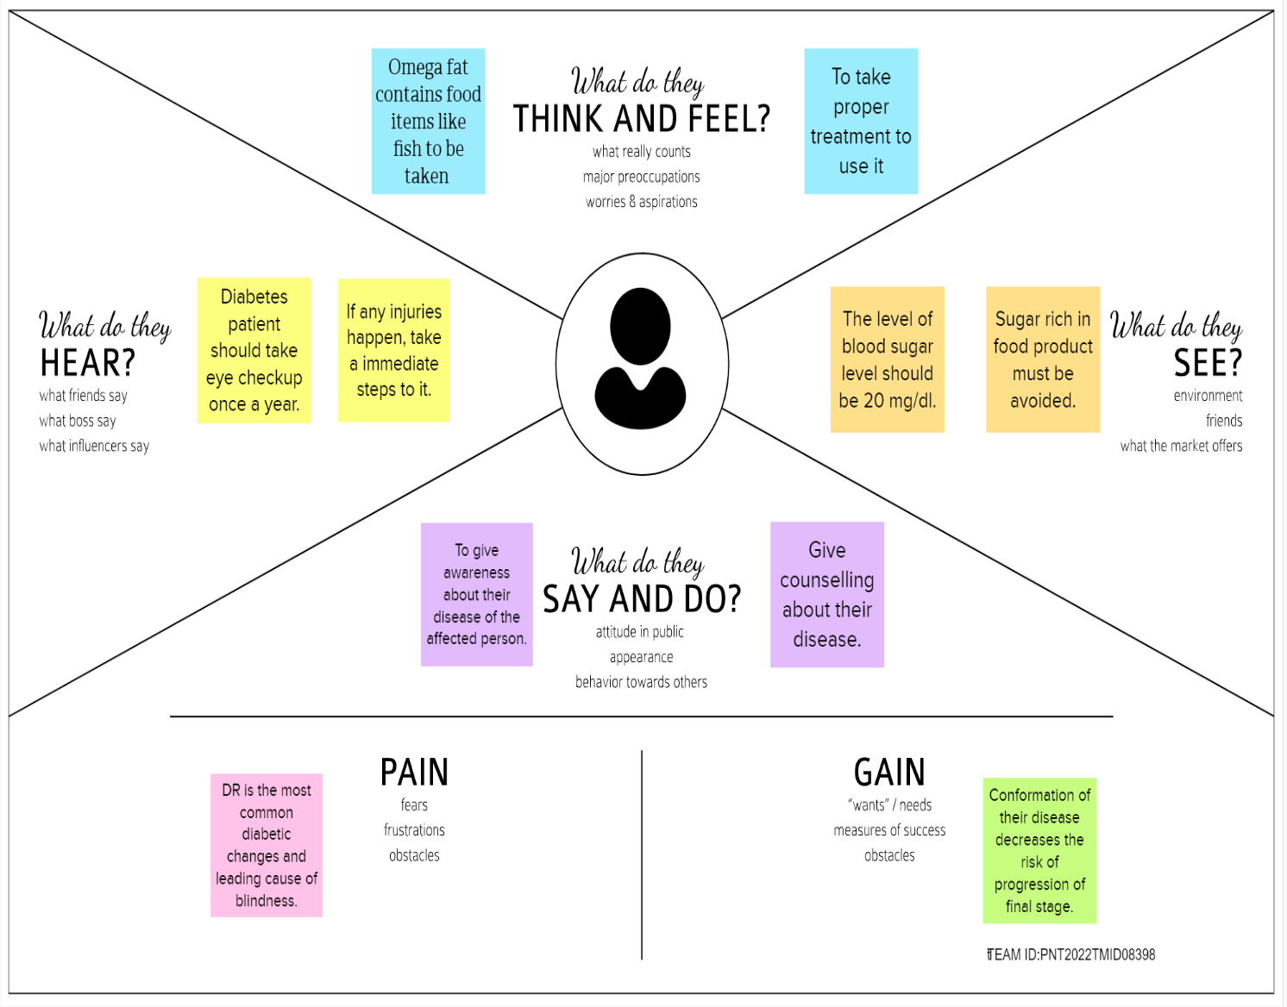

**3.2 IDEATION AND BRAIN STORMING:**

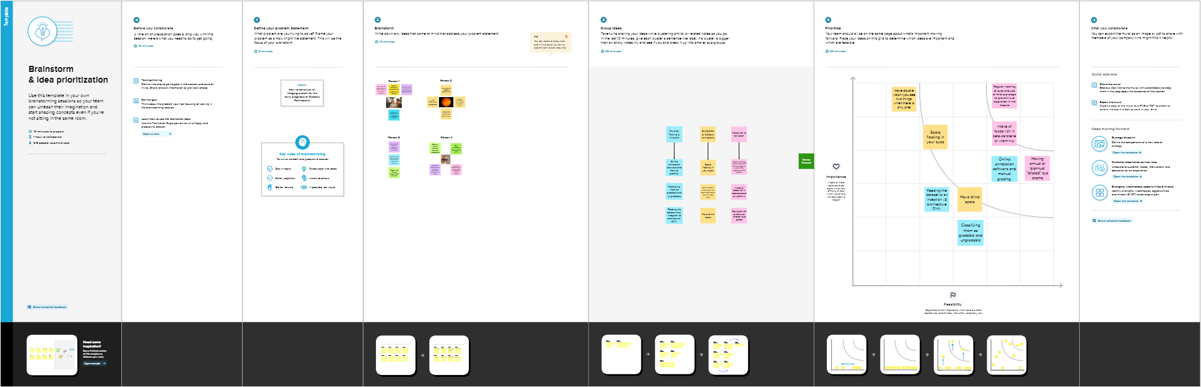



**3.3 PROPOSED SOLUTIONS:**

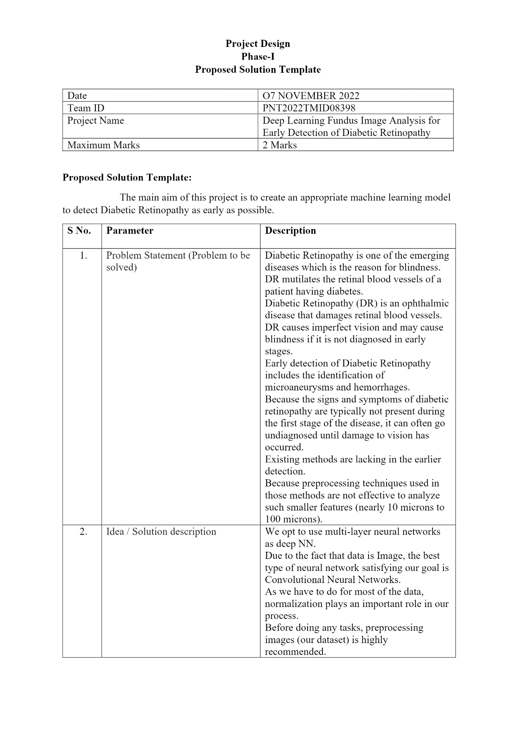

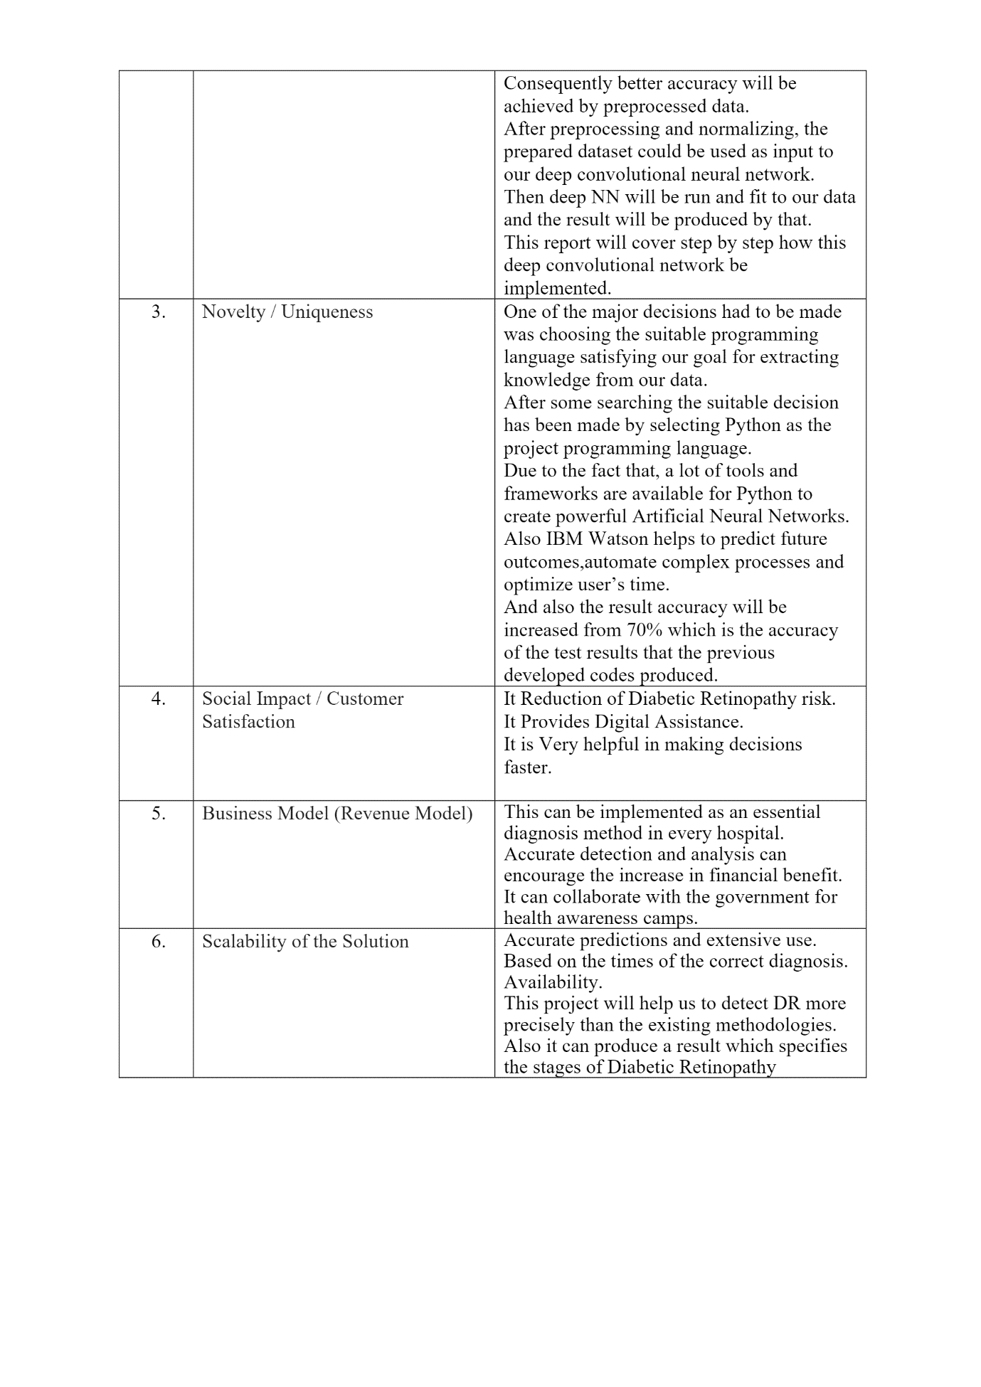

**3.4 PROBLEM SOLUTION FIT:**

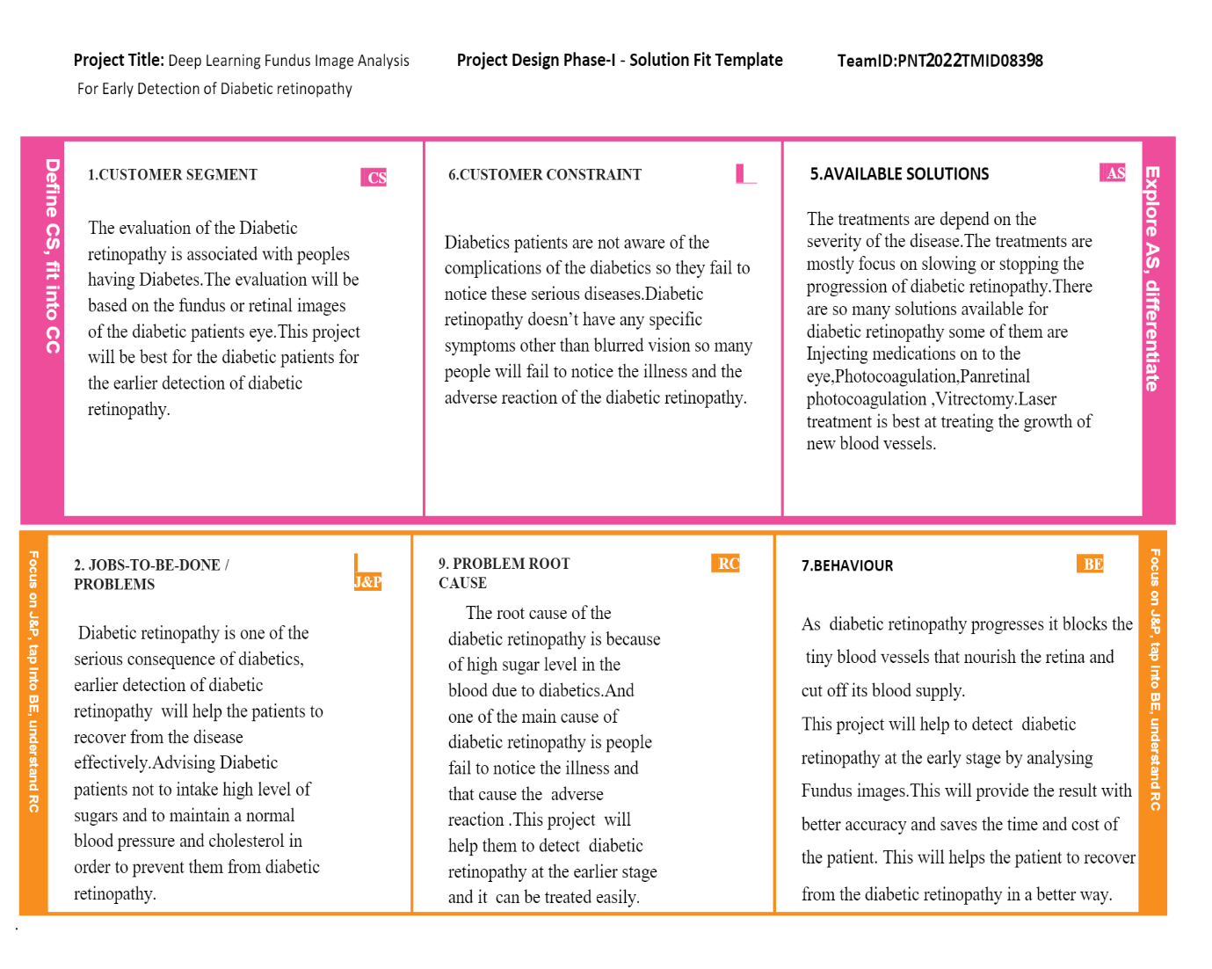

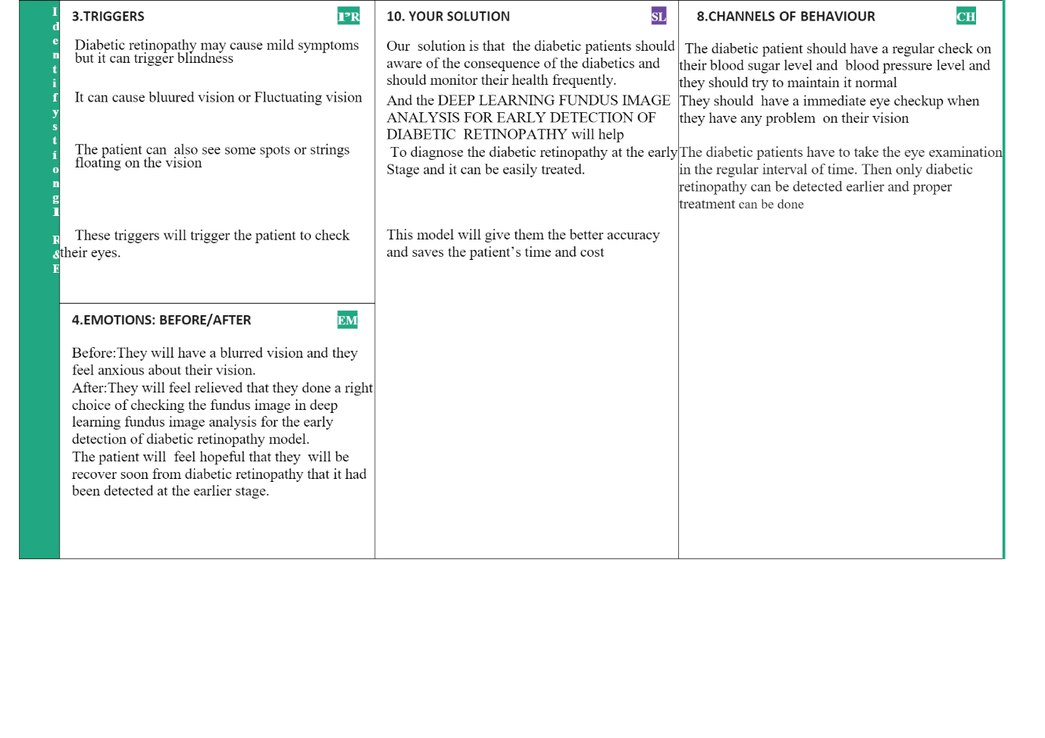

**4. REQUIREMENT ANALYSIS:**

**4.1 FUNCTIONAL REQUIREMENT:**

In functional requirement of the image processing algorithm has been using python language

**4.2 NON -FUNCTIONAL REQUIREMENT:**

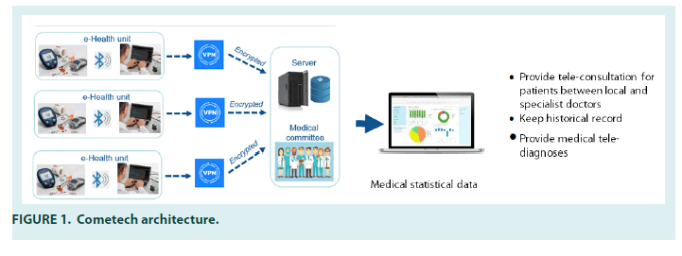

**5. PROJECT DESIGN:**

**5.1 DATA FLOW DIAGRAMS:**

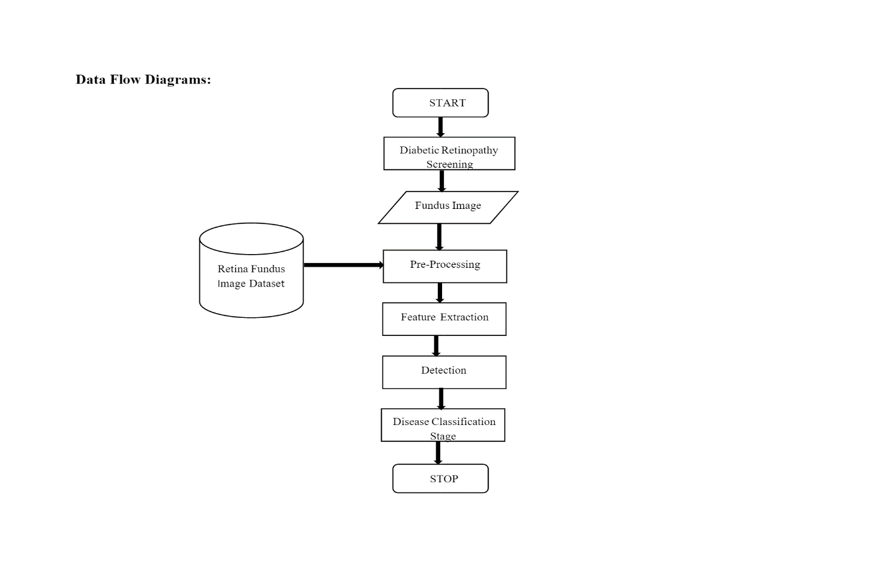

**5.2 USER STORIES:**

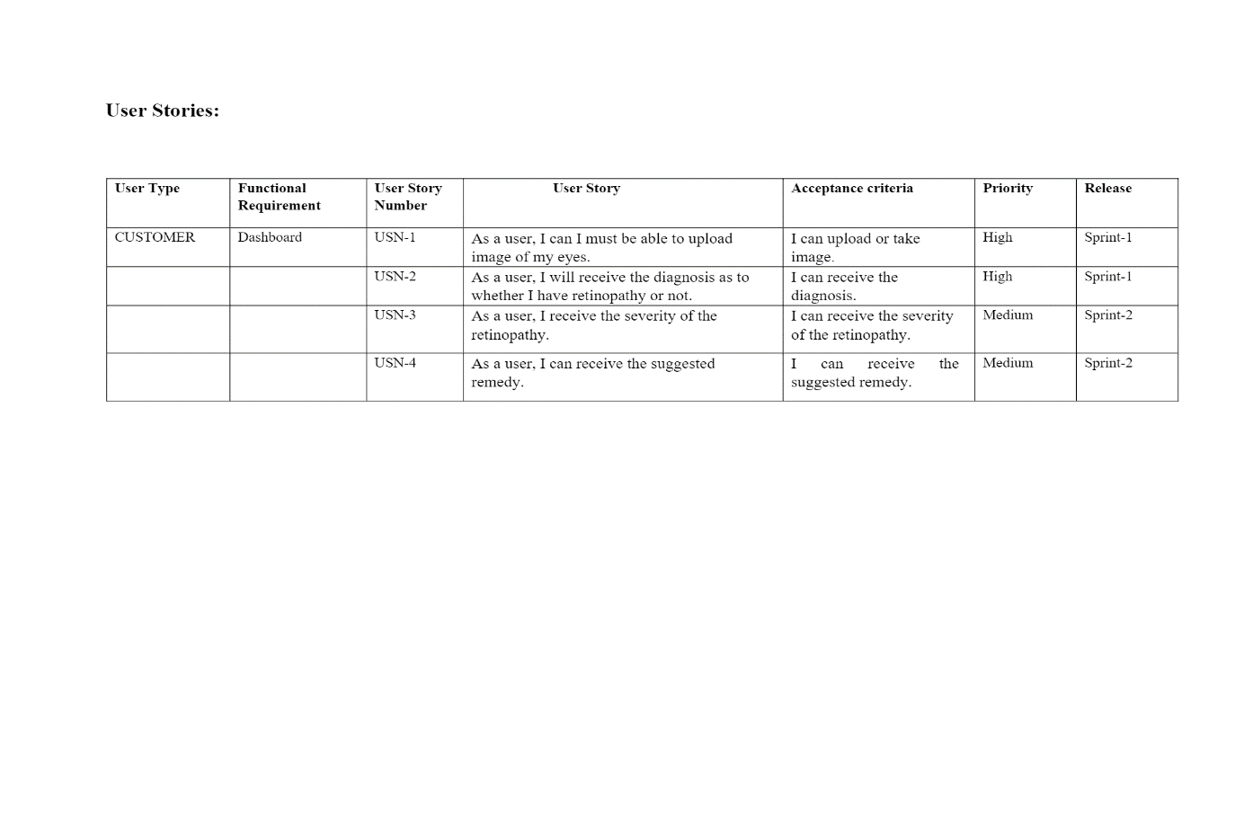

**6. SOLUTIONS AND TECHNICAL ARCHITECTURE:**

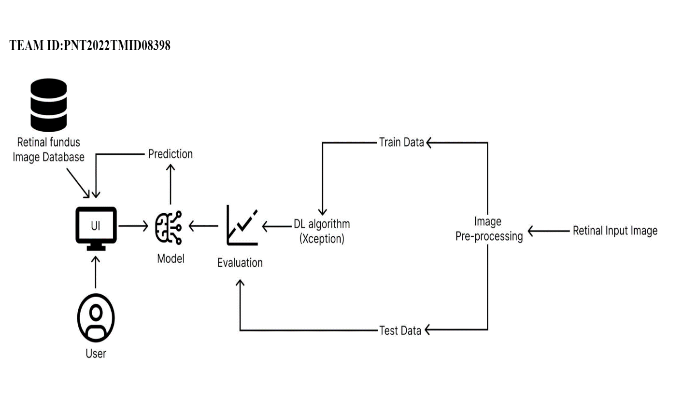

**7.PROJECT PLANNING AND SCHEDULING:**

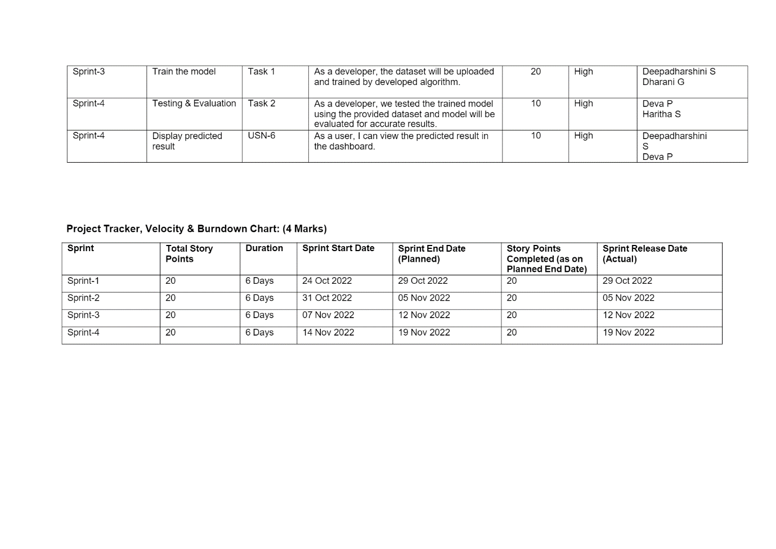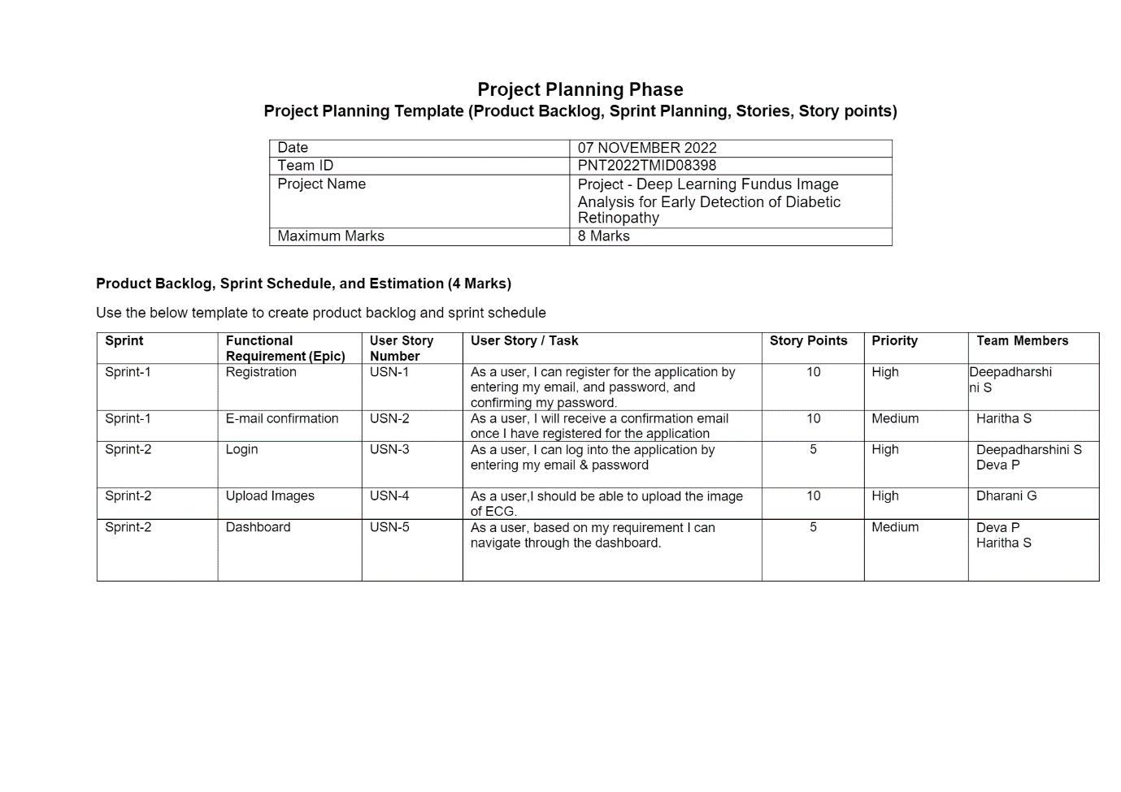

**8 ADVANTAGES&DISADVANTAGES:**

**ADVANTAGES :**

* Nearly Accurate Detection of Glaucoma compared to

existing approaches.

* The noise content present in the retinal image is removed

Properly

* Segmentation results of Optic disc and Optic cup regions

are better.

* The input retinal image is properly classified as normal or

moderate or severe based on CDR ratio**.**

**DISADVANTAGES:**

* They do not take into consideration of the noise or the image normalizationin the input retinal image.
* These methods does not show high contrast image for the output image.
* Manual assessment is subjective, time consuming and expensive.
* Poor and Inaccurate segmentation results
* All Optic disc like regions are misclassified since it is hard to distinguishfrom fragments of the vascular system or from certain eye feature.

**10 CONCLUSION:**

Glaucoma could be detected using the deep features highlighted by thevisualized maps of pathological areas, based on the predicted attentionmaps. For training the AG-CNN model, we established the LAG databasewith 11,760 fundus images labeled as positive or negative glaucoma. Atotal of 5,824 images in our LAG database have the attention map onglaucoma detection obtained from 4 ophthalmologists. The experimentresults show that the predicted attention maps improve the performance ofglaucoma detection and pathological area localization in our AG-CNN method, far better than other state-of-the-art methods.

**12 FUTURE SCOPE:**

In future, many more features can be extracted from attributes such as red lesions, Kapoor entropy, edema, etc. Detection of Micro-aneurysm and also maculopathy be predicted and performance can be compared. The Learners can be used for classification of diabetic retinopathy images in multiple classes based on the features values and performance may be evaluated on different measures.

**CODE AND IMPLEMENTATION**

PACKAGES

!pip install -q visualkeras

!pip install -q ann_visualizer

!pip install -q dtreeviz

import numpy as np

import pandas as pd

import matplotlib.pyplot as plt

import tensorflow as tf

from tensorflow import keras

from tensorflow.keras.preprocessing.image import ImageDataGenerator

from tensorflow.keras.layers import BatchNormalization

from tensorflow.keras.models import Sequential

from tensorflow.keras.layers import Conv2D

from tensorflow.keras.layers import Flatten

from tensorflow.keras.layers import MaxPooling2D

from tensorflow.keras.layers import Dropout

from tensorflow.keras.layers import Dense

from tensorflow.keras.layers import Activation

from tensorflow.keras.models import Model

from tensorflow.keras.optimizers import Adam

from keras import regularizers

## TO VISUALIZE

from tensorflow.keras.preprocessing import image

import visualkeras

from ann_visualizer.visualize import ann_viz

from dtreeviz.trees import *

from tensorflow.keras.utils import plot_model

## TO IGNORE WARNINGS

import warnings

warnings.filterwarnings('ignore')

from google.colab import drive

drive.mount('/content/drive')

% Filtering out corrupted images

import os

num_skipped = 0

for folder_name in ('Mild', 'No_DR', 'Proliferate_DR', 'Severe'):

    folder_path = os.path.join(data_dir, folder_name)

    for fname in os.listdir(folder_path):

        fpath = os.path.join(folder_path, fname)

        try:

            fobj = open(fpath, "rb")

            is_jfif = tf.compat.as_bytes("JFIF") in fobj.peek(10)

        finally:

            fobj.close()

        # if not is_jfif:

        #     num_skipped += 1

        #     # Delete corrupted image

        #     os.remove(fpath)

print("Deleted %d images" % num_skipped)

datagen = ImageDataGenerator(

        rescale = 1./255,

        rotation_range = 40,

        width_shift_range = 0.2,

        height_shift_range = 0.2,

        shear_range = 0.2,

        zoom_range = 0.2,

        horizontal_flip = True,

        fill_mode = 'nearest',

        validation_split = 0.2)

height = 224

width = 224

channels = 3

batch_size = 32

img_shape = (height, width, channels)

img_size = (height, width)

train_data = datagen.flow_from_directory(

    data_dir,

    target_size = img_size,

    batch_size = batch_size,

    class_mode = 'categorical',

    subset = 'training')

val_data = datagen.flow_from_directory(

    data_dir,

    target_size = img_size,

    batch_size = batch_size,

    class_mode='categorical',

    subset = 'validation')

## lests create helper function

def plotImages(image_arr):

    fig,axes = plt.subplots(1, 5, figsize=(20,20))

    axes = axes.flatten()

    for img,ax in zip(image_arr,axes):

        ax.imshow(img)

    plt.tight_layout()

    plt.show()

model building

# Model building

# Model building

#Instatiating A convnet

model = Sequential()

model.add(Conv2D(16, (3,3), input_shape=(224,224,3), activation="relu"))

model.add(MaxPooling2D(pool_size = (2,2)))

model.add(Conv2D(32, (3,3), activation="relu"))

model.add(MaxPooling2D(pool_size = (2,2)))

model.add(Conv2D(64, (3,3), activation="relu"))

model.add(MaxPooling2D(pool_size = (2,2)))

model.add(Flatten())

model.add(Dropout(0.2))

model.add(Dense(128,activation="relu"))

model.add(Dropout(0.2))

model.add(Dense(4, activation="softmax"))

model.compile(

    optimizer = "adam",

    loss = "categorical_crossentropy",

    metrics = ['accuracy']

)

model.summary()

**training and testing of dataset**

STEP_SIZE_TRAIN = train_data.n // train_data.batch_size

STEP_SIZE_VALID = val_data.n // val_data.batch_size

history = model.fit_generator(train_data,

                    steps_per_epoch = STEP_SIZE_TRAIN,

                    validation_data = val_data,

                    validation_steps = STEP_SIZE_VALID,

                    epochs = 30,

                    verbose = 1)

**RESULTS AND SCREEN SHOT**

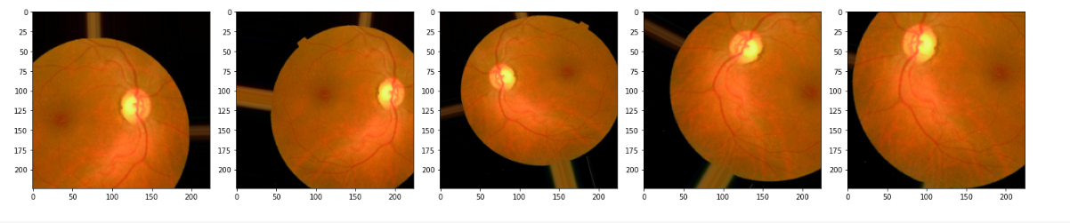

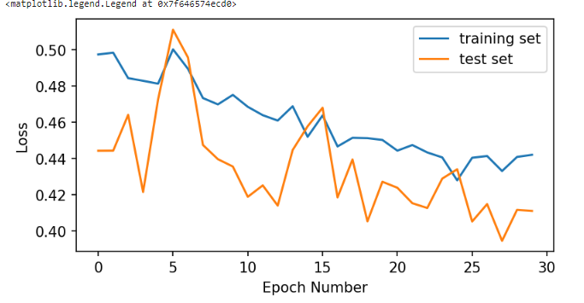

**Training loss**

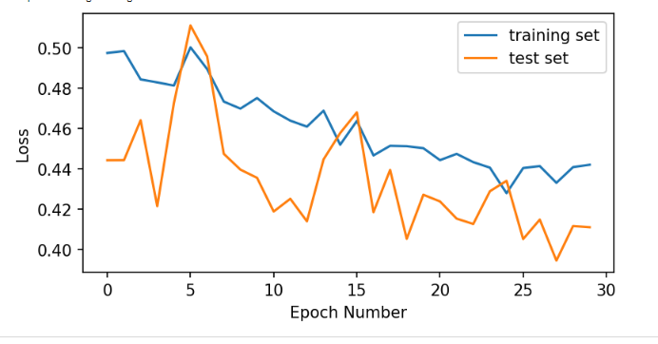

**GitHub & Project Demo Link:  
GitHub:**

<https://github.com/IBM-EPBL/IBM-Project-9489-1659011852>

**Project Demo Link:**

**EXECUTION LINK (ONLY EXECUTION):**

**Google Drive Link:**

<https://drive.google.com/file/d/1-anmrIjGSGdPQNebqwGz3fGvpV9_kzwP/view?usp=share_link>

**YOUTUBE LINK:**

<https://youtu.be/aiqhyQQHeTE>